Contents

1. Pre-Requisites for Automation Execution 3

1.1 Browsers Settings 3

1.2 Configuration of “config.properties” file 4

1.3 Prerequisites for Execution of ‘Scenario: Precondition-’ …………………………………………………………7

2. [Compatibility of Automation Project](#_Toc488320893) 5

2.1 Browsers and Operating Systems used 6

3. Download & Install AutoIT and Configure 7

3.1 Download and Install AutoIT 8

3.2 Configure the Script Editor 9

4. Download and Install JDK8 11

4.1 Download JDK8 from link 11

4.2 Set Environment Variable and path for JDK8 11

5. Install Maven 12

5.1 Download Apache Maven 12

5.2 Set Environment Variable path 12

6. Install Eclipse 13

6.1 Download Eclipse 13

6.2 Open Eclipse 13

7. Import Project to Maven 14

7.1 Create Sample Maven Project 14

7.2 Import Existing File of Maven Project to Eclipse……………………………………………………………………15

8.  [Configure the Code into Script Editor](#_Toc488320892) 1

9.Run the Project from Eclipse 16

9.1 To Execute a Single feature file in the Cucumber Project 16

9.2 Run the Feature file 17

9.3 To Execute the .feature files in a Batch 18

9.4 Execute feature files in each Functionality level 18

9.5 Mention the Tag name in the TestRunnerNew.java class 18

9.6 To Execute All Functionality Master Feature files togather 19

10. Download and Install Jenkins 20

10.1 Download Jenkins 21

10.2 Extract & Install Jenkins 22

10.3 Creation of User 23

10.4 Create and Build a Project through Jenkins 25

10.5 Cucumber Reports 26

11. Clone the Code from Stash and Import the same folder to Eclipse 27

11.1 Clone the Latest code from Stash 27

11.2 Import that Folder to the Eclipse Workspace 28

11.3 Run the feature file 28

12.Limitations of Automation Project 29

13. How to rerun the failure test script……………………………………………………………………………………………36

# 1. Pre-Requisites for Automation Project

* **AutoIT Configuration :**
* We need to Configure AutoIT in the Local Machine to Run the Automation for Windows based Operations(Ex: Importing the Files from Machine etc)
* AutoIT works fine with the Windows Environment.
* Follow the AutoIT Installation Steps in Step 8.

1.1 **Browser Settings**

* **Internet Explorer**

1) Go to Tools > Internet Options and Under Internet Options click on the Security tab.

2) Click on the Internet zone to select a zone and to view its Protected Mode property.

3) Now check the Enable Protected Mode check-box. Whichever one you choose, needs to be set for all the other zones. Means either it can be OFF for all the zones or ON for all the zones.

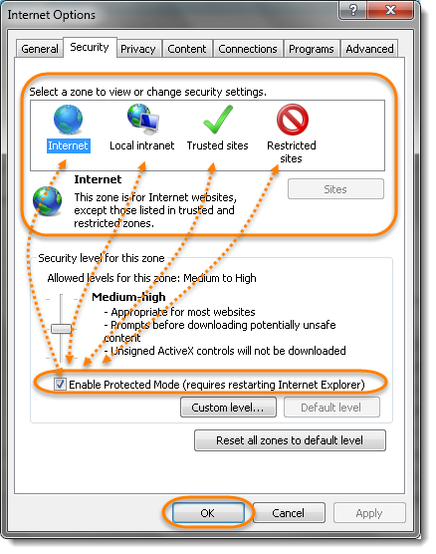

4) Repeat this above steps for all the zones

5)  Internet Explorer Zoom level should be set to 100%

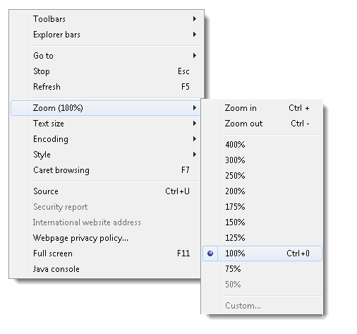

**1.2 Configuration of “config.properties” file**

**\*** Use the **Config**.**properties** file for the **Credential** Modifications. (Login with the Different Credentials by passing through the config.properties file in the Project folder)

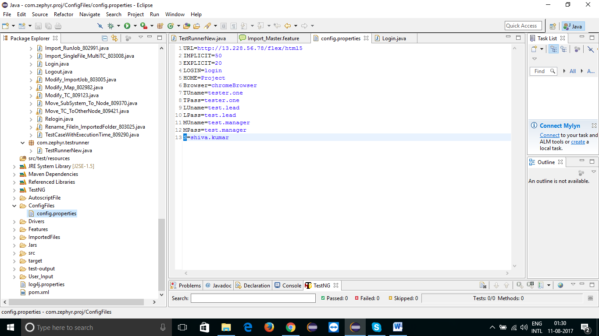

*We can Variables for **Implicit** wait and **Explicit** wait to wait for the specific Element to be displayed in the Required UI location.

*We can pass the **URL** of the Application and **Browser** **type** (Browser you want to launch) in the config.properties file.

*Store your Credentials in variables and Use the same variable in the Username and Password Path in the Login.java class

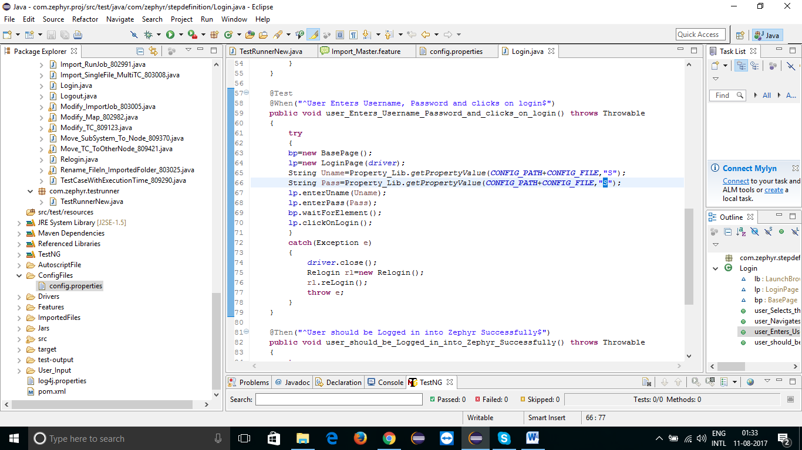

**1.3 Prerequisites for Execution of ‘Scenario: Precondition-’**

1. You need to create the Projects, Releases and assign the users to the projects manually and add the Created project name, user credentials in config. properties.

2. If you are running the scripts in new release for the first time then execute the precondition (present in particular master features files)

3. If you are running the script in same release (where already scripts had run once) then no need of executing precondition just comment the precondition in feature files and execute the scenarios.

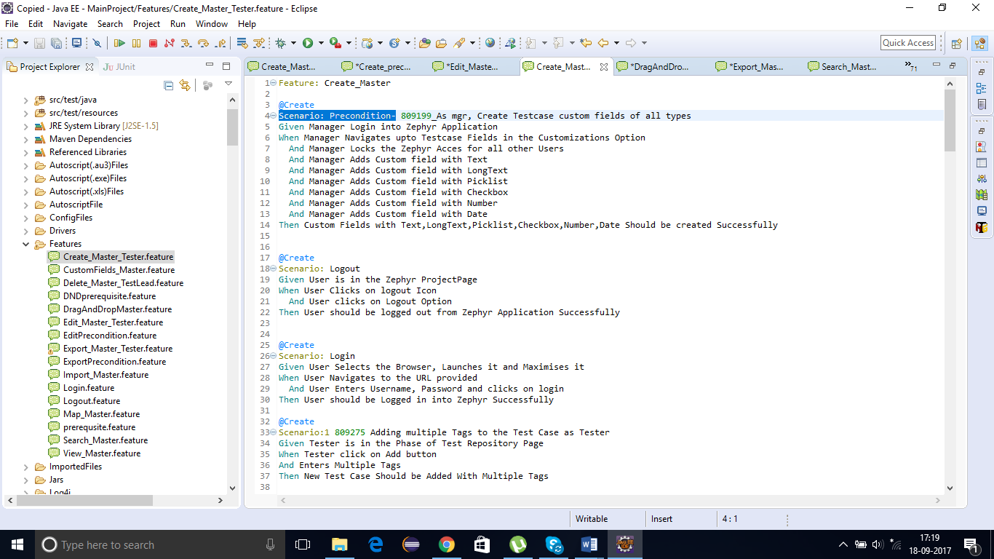

# 2. Compatibility of Automation Project

**2.1 Browsers and Operating systems Used**

|  |  |
| --- | --- |
| **Browsers** | **Operating Systems** |
| **1.Internet Explorer** | **1.Windows 7** |
| **2.FireFox Browser** | **2.Windows 8** |
| **3.Chrome Browser** | **3.Windows 10** |

# 3. Download & Install AutoIT and Configure it

3.1 Download and Install AutoIT and Editor

* Download AutoIT .exe file by following link - -> > <https://www.autoitscript.com/site/autoit/downloads/>

* Click On “Download AutoIT” and Install it.



* Click On “Download Editor” and Select [SciTE4AutoIt3.exe](https://www.autoitscript.com/cgi-bin/getfile.pl?../autoit3/scite/download/SciTE4AutoIt3.exe) file. Download and Install it.



4. Download and Install JDK

4.1 Download JDK8(or Latest) from link - >> http://www.oracle.com/technetwork/java/javase/downloads/jdk8-downloads-2133151.html

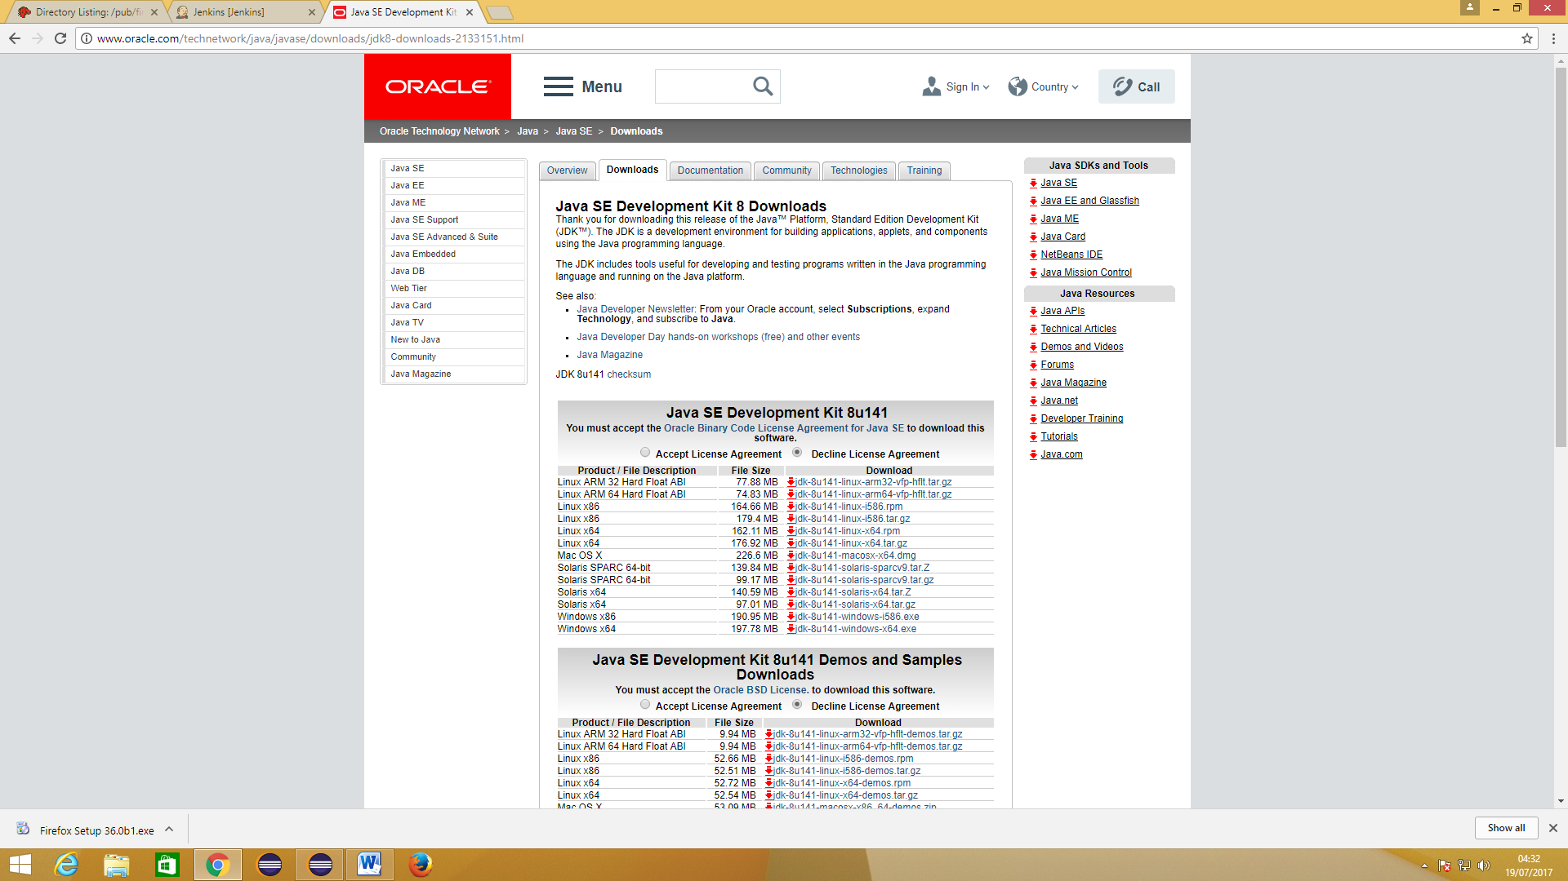

## 4.2 Set Environment Variable and path for JDK

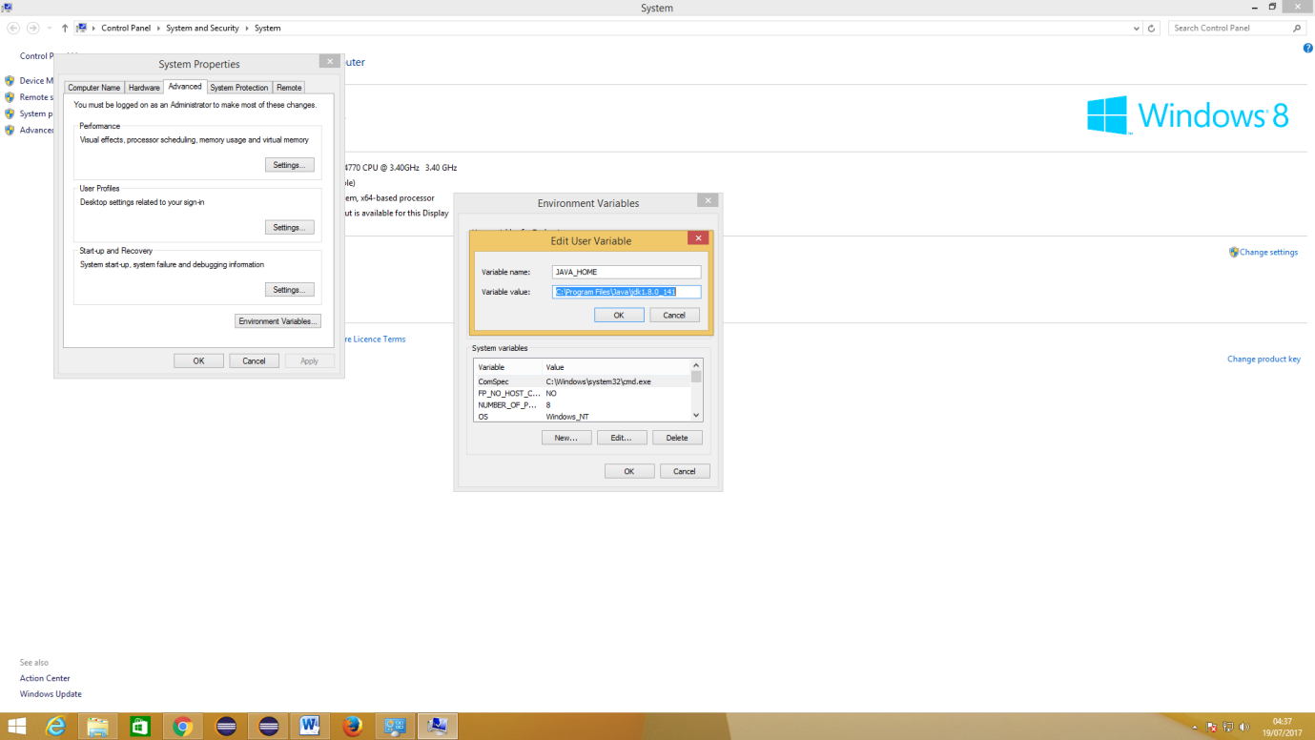

# 5.Install Maven :

5.1 Download apache-maven-3.5.0-bin.zip file from link (3.5.0(or latest) from Apache Maven Project and Set Environment Variable) - >> <https://maven.apache.org/download.cgi>

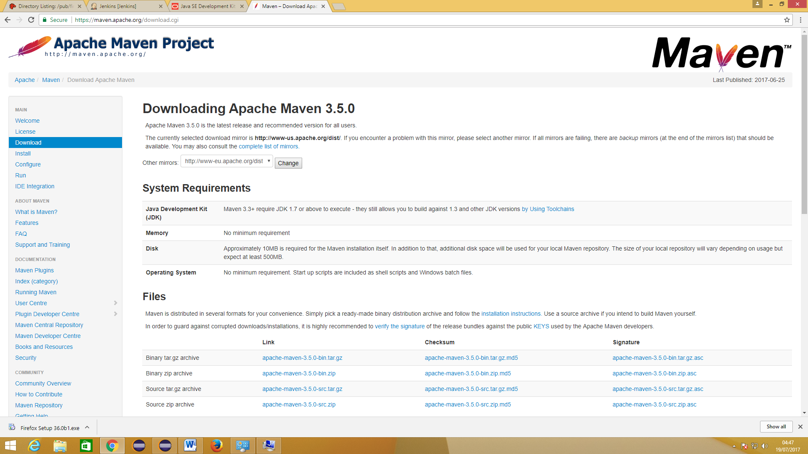

5.2 Set Environment Variable path for Maven

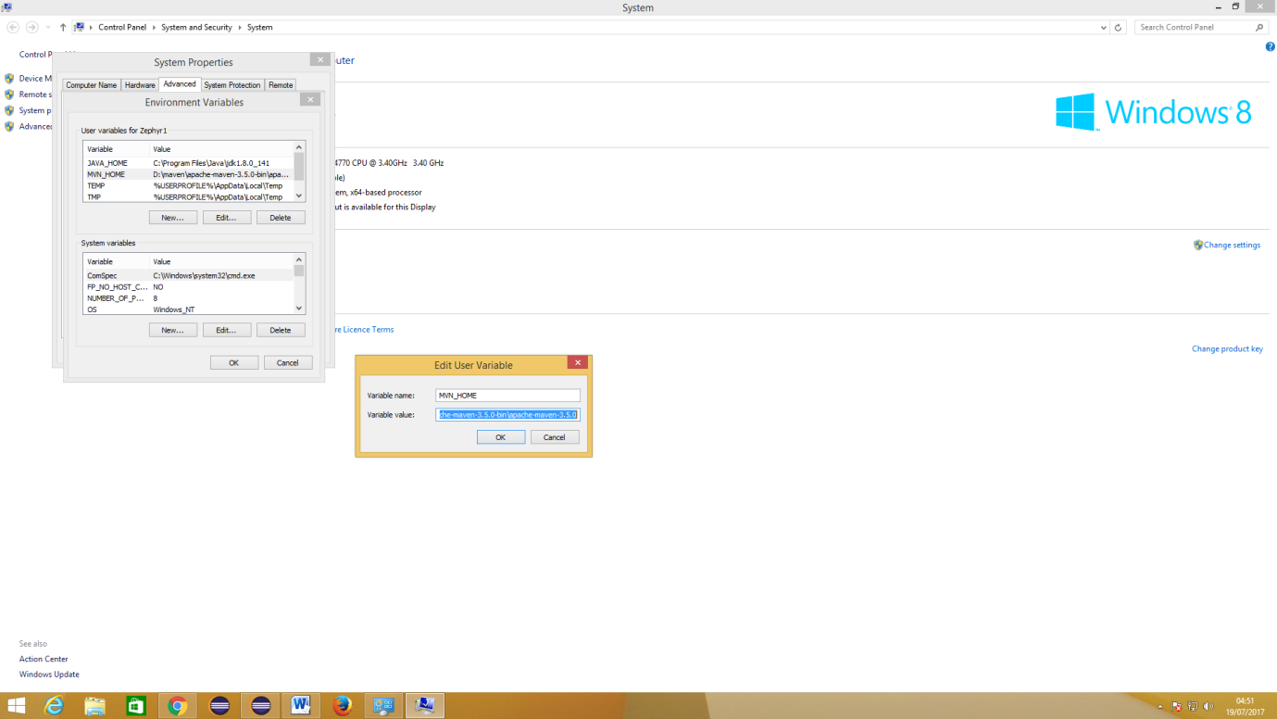

# 6. Install Eclipse

6.1 Download Eclipse Luna (or latest) from link - >> <https://eclipse.org/downloads/packages/eclipse-ide-java-ee-developers/lunar>

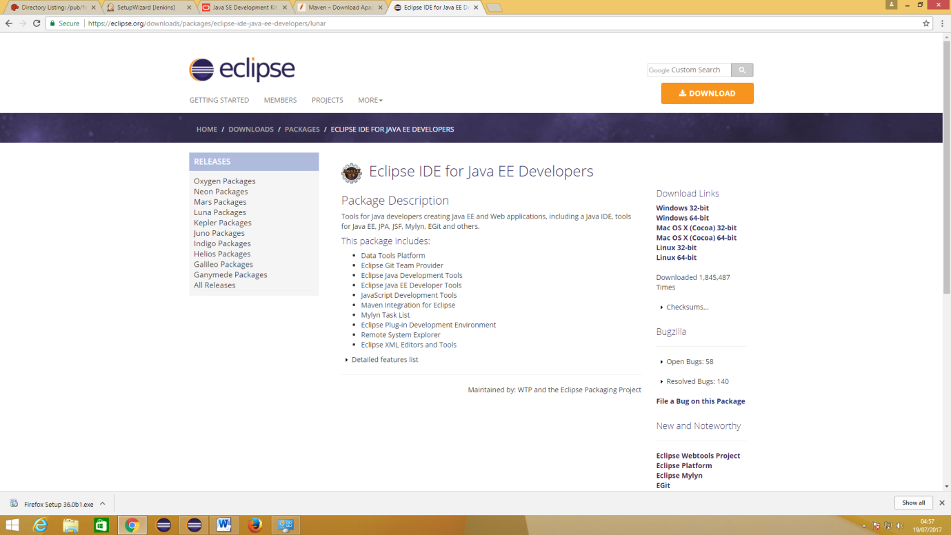

6.2 Open Eclipse: Navigate to eclipse Application file inside the folder and Open Eclipse Application

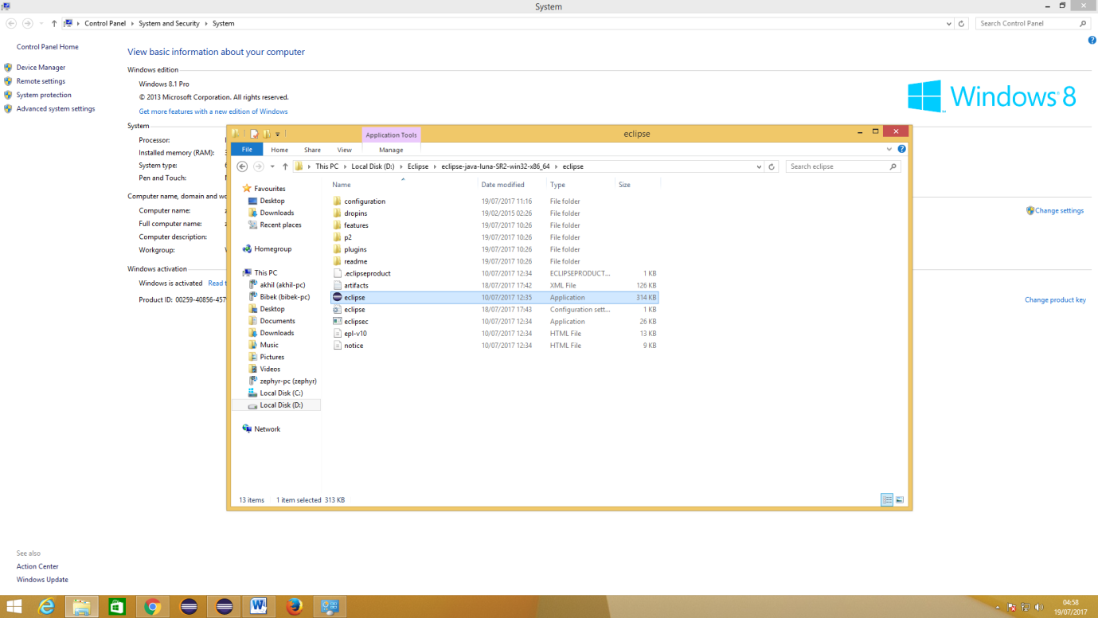

7. Import Project to Maven: Create Maven Project and Import project set up

7.1 Create Sample Maven Project

* Go to File - > New -> Project -> Maven Project

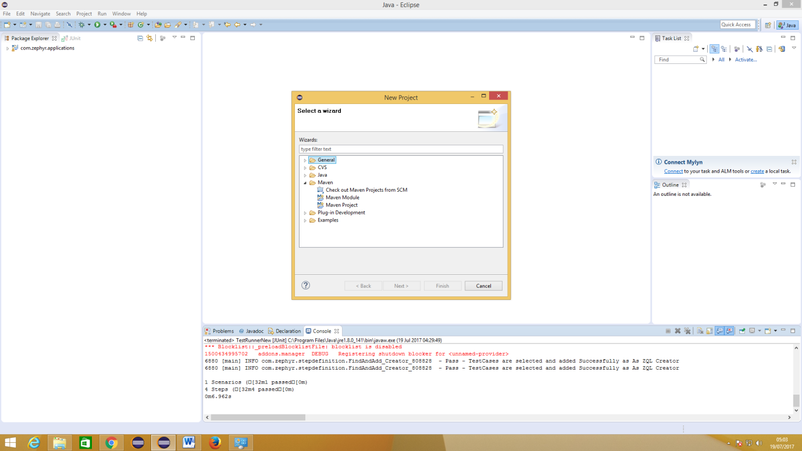

7.2 Import Existing File of Maven Project to Eclipse

* Click on Import

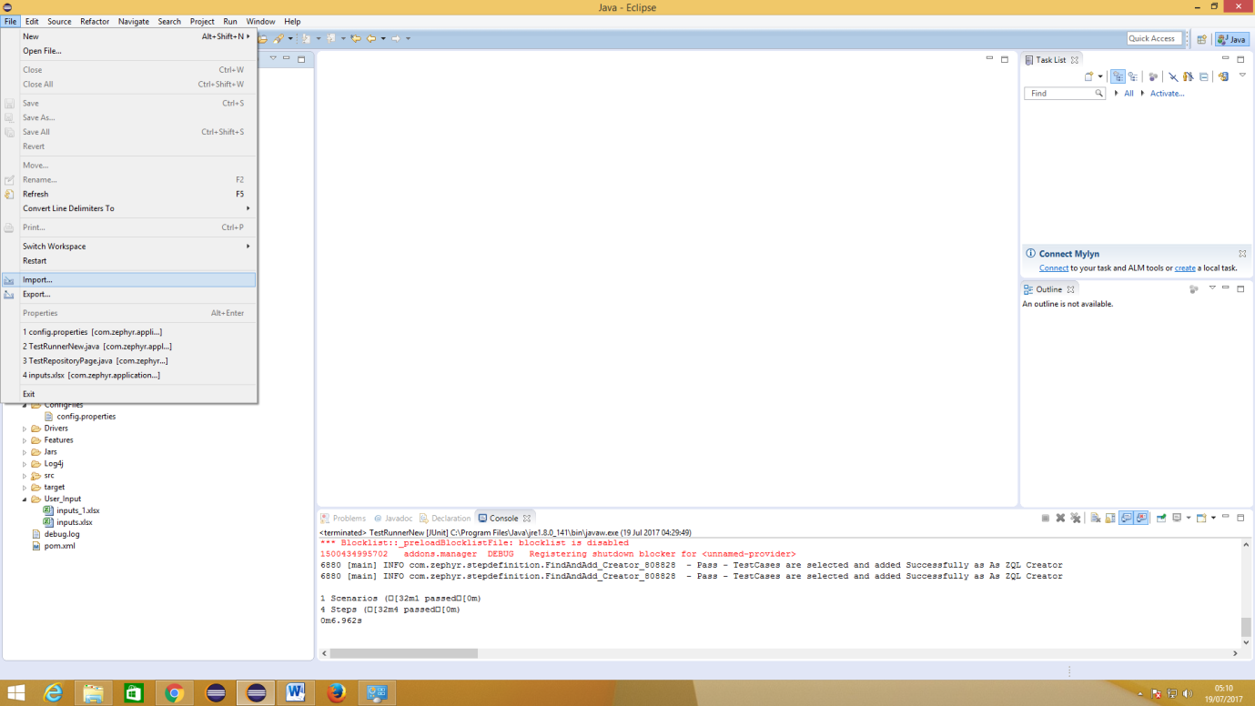

*Select File Path of Project

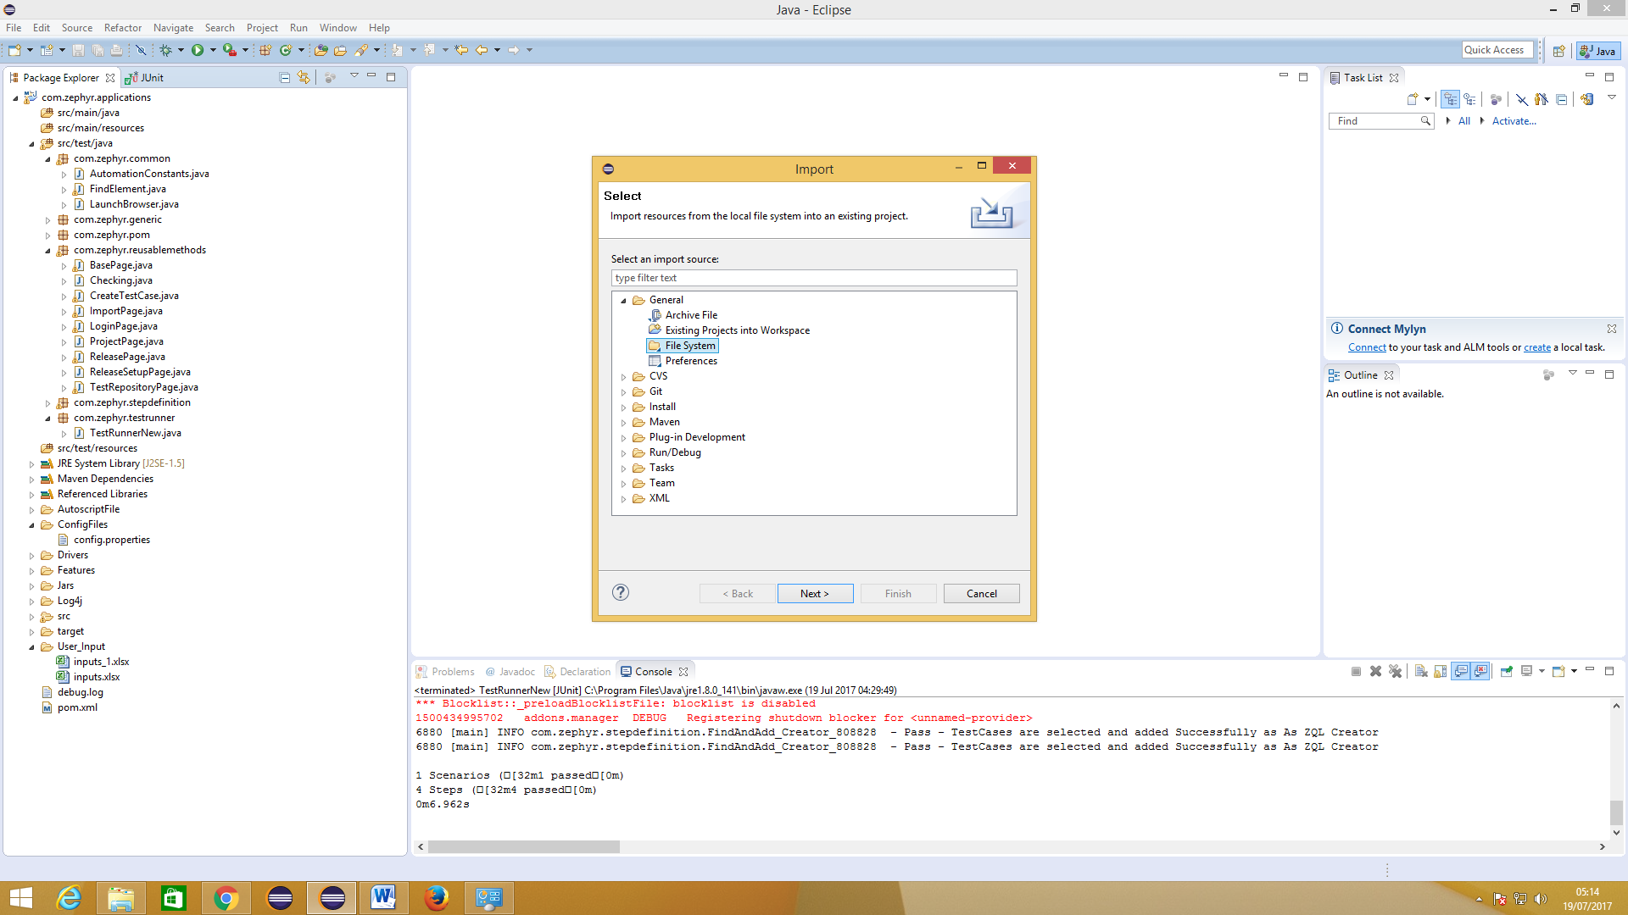

*Update the Project you have imported to the Workspace in Eclipse

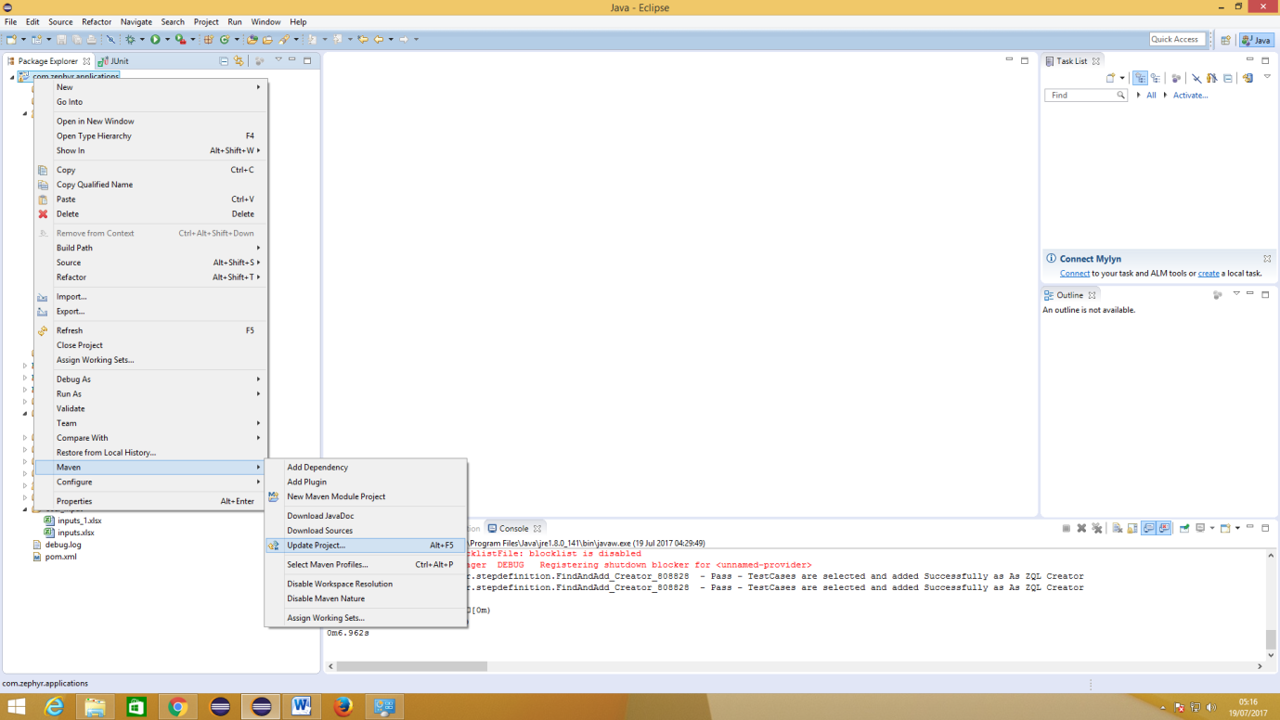

8. Configure File in Auto IT and Editor

8.1 Configure File in Auto IT and Editor

* Copy .au3 files located in the Folder name “Autoscript(.au3)Files” inside project to your local path.

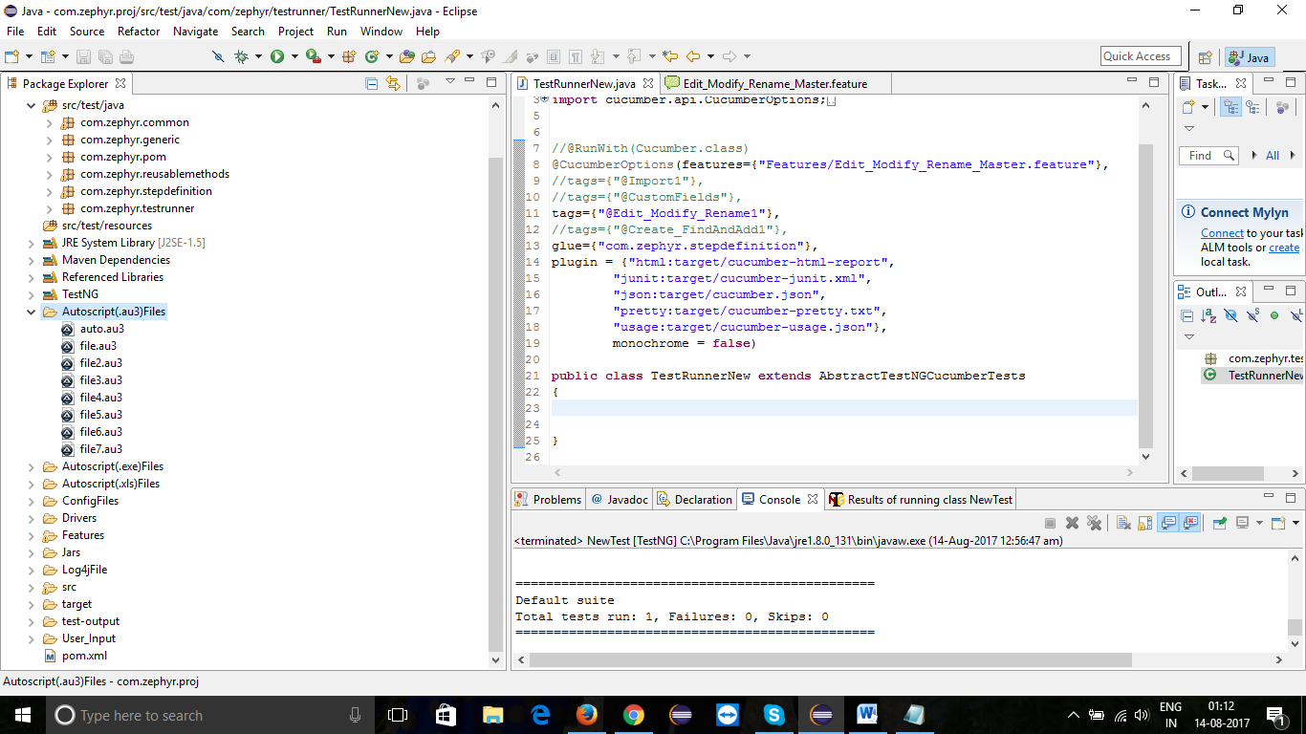

* Copy .au3 files located in the Folder name “Autoscript(.au3)Files” inside project to your local path.

* Copy .xls files located in the Folder name “Autoscript(.xls)Files” inside project to your local path.

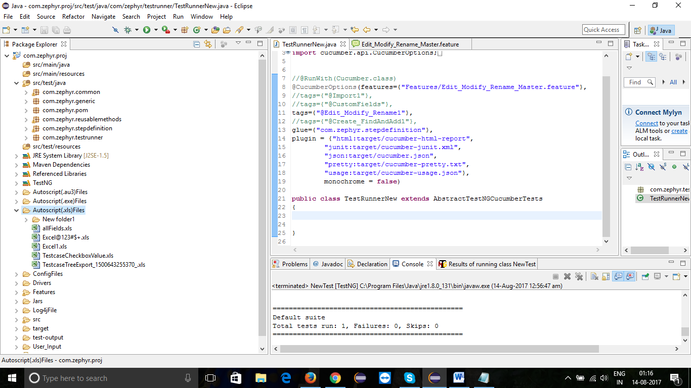

* Go to .au3 file -- >> Right Click -- >> Select “Edit Script”.

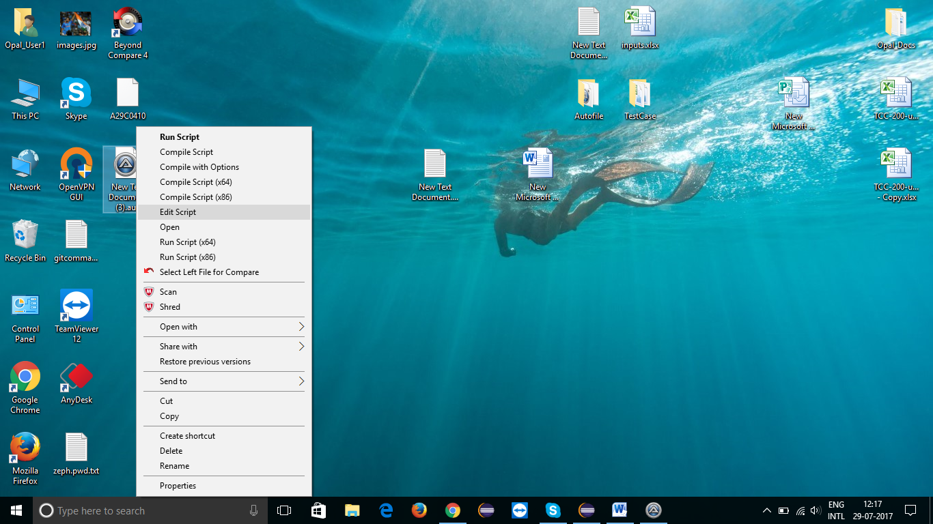

8.2 Configuring the Code into Editor

* Change the path of “ControlSetText” (Highlighted with merun color) to your Local path in the editor.

* Make sure that Filename (ex: Excel1.xls) remains Unchanged.

ControlFocus ( "Open", "", "Edit1" )

ControlSetText("Open","","Edit1"**,"C:\Users\Opal_User1\Desktop\TestCase\Excel1.xls**")

ControlClick("Open","","Button1")

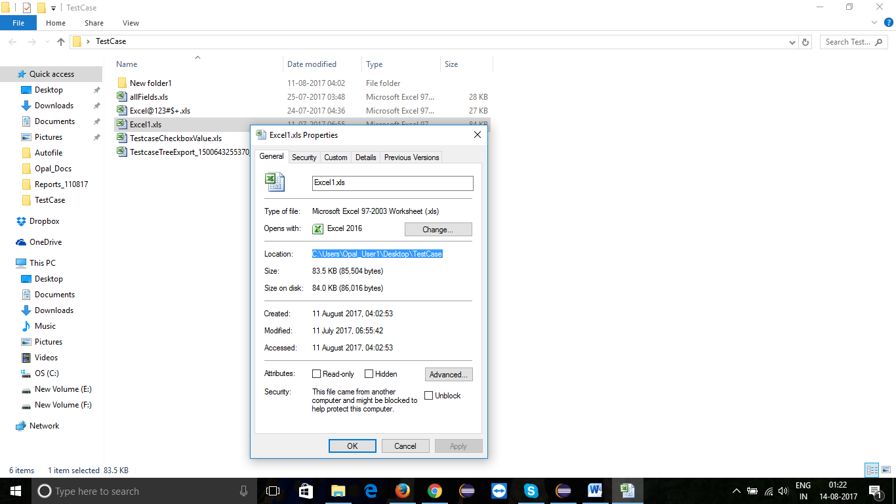

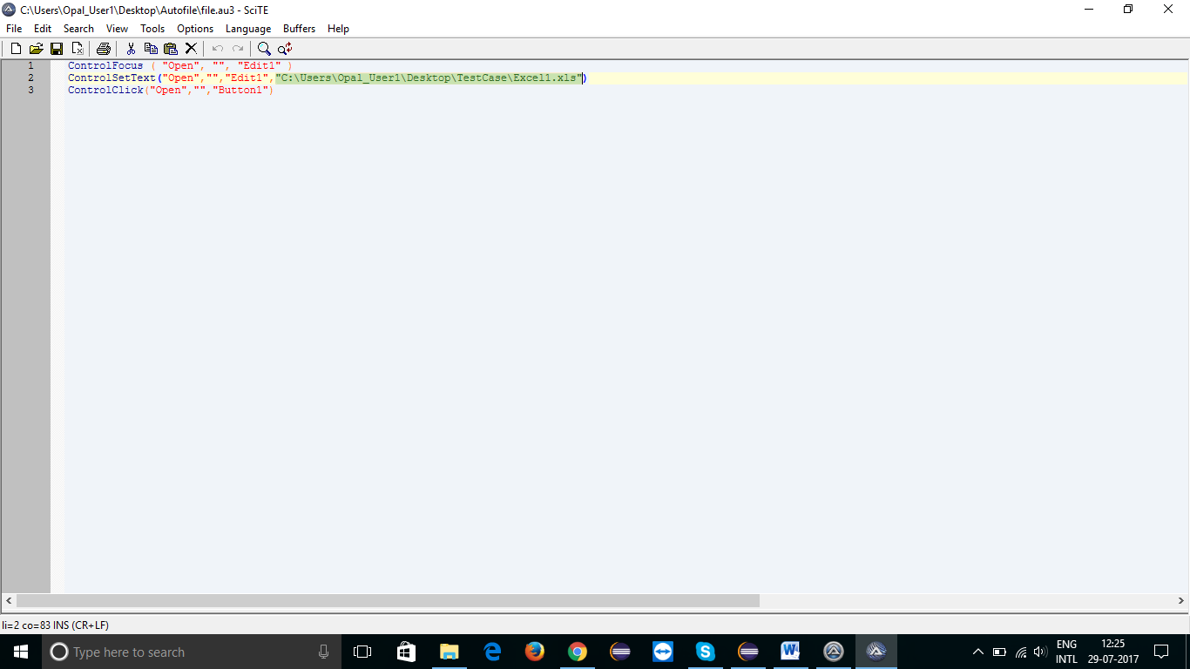

* Save the file and Compile the script

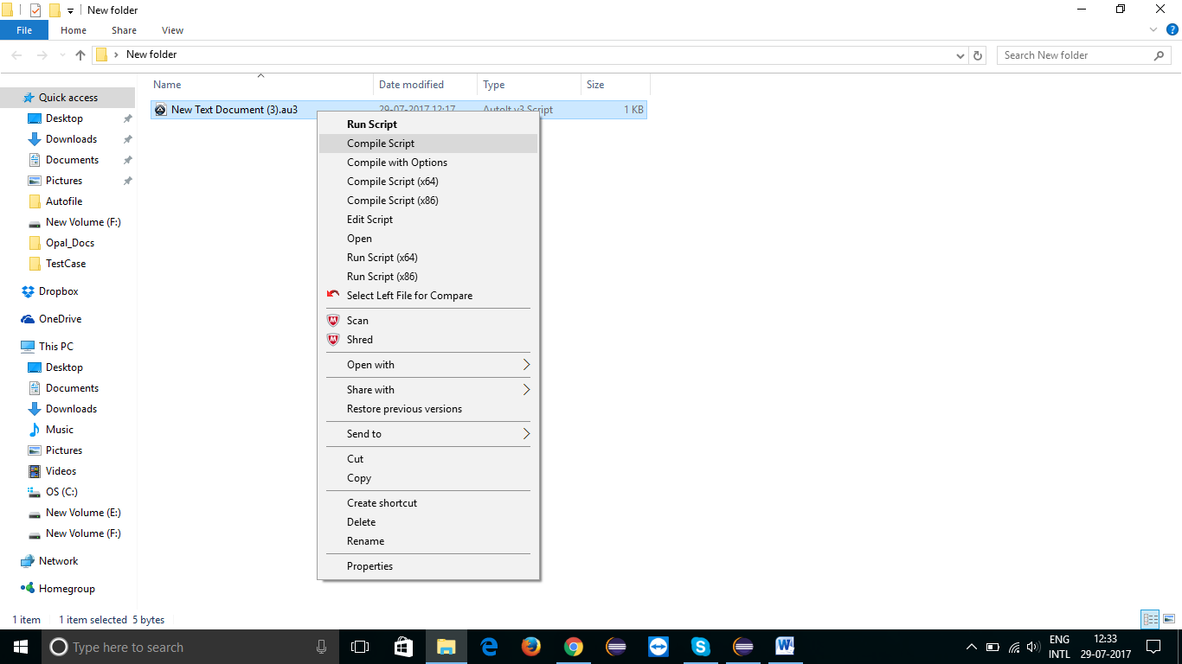

* It generates an “.exe” file of the Script file.

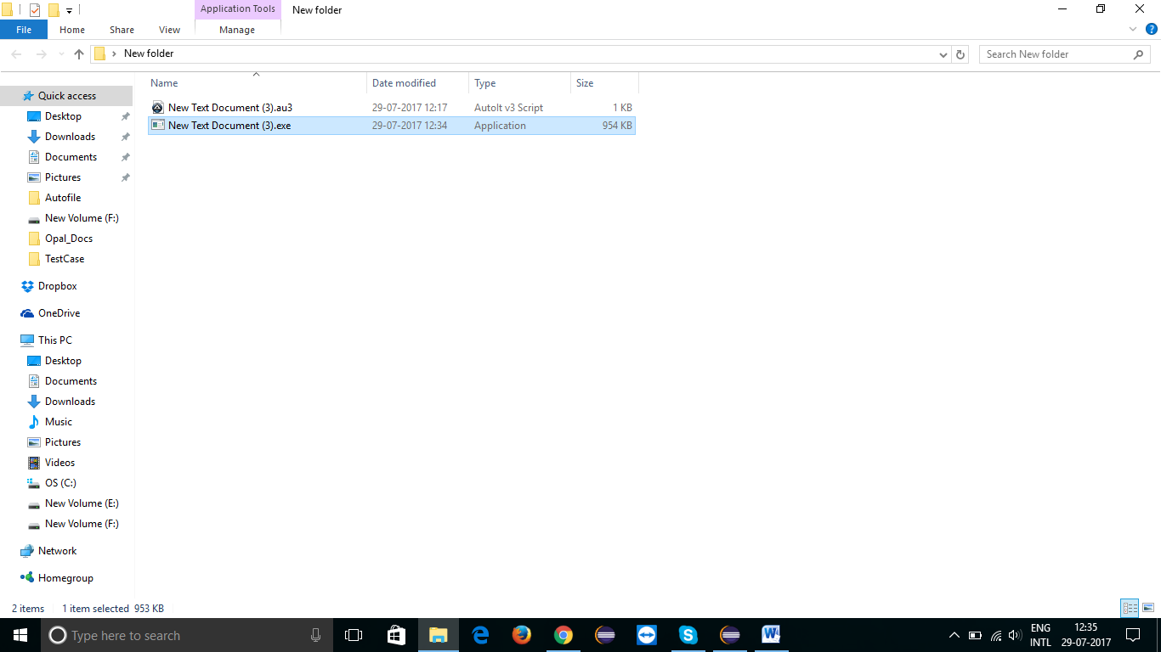

* By following above steps .exe files are generated for the all .au3 files.

* After converting all (.au3) files into (.exe) files , Go to-- >>“Autoscript(.exe)Files” folder and delete already present .exe files in the folder if any.

* Paste all the newly generated (.exe) files into the “Autoscript(.exe)Files” folder of the Project.

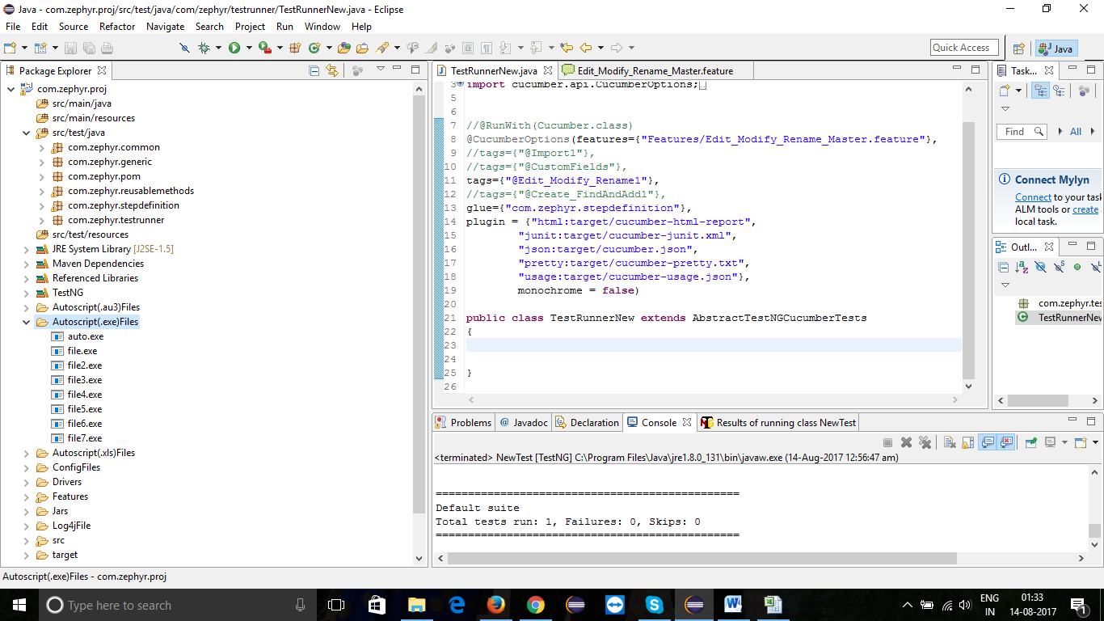

* Now AutoIT scripts are ready for the execution.

9. Run the Project from Eclipse

9.a Pre-Requisites for Execution

* If the Execution are run for the first time in a new release setup following have to be done.
  + Project, Release, Users and user association with respective projects have to done manually.
  + Pre condition scenarios (with Name: Precondition) have to be run which creates Custom fields, Phases, Systems and Subsystems.
* If the Execution is run for on the same release second time onwards, Pre condition scenarios need to be commented to avoid creation of test data again.
* If the tests are run on a new release with pre requisite data creation step, count value in “Config2.properties” has to be set to new unique value to avoid duplicate data creation.
* Do Auto It configuration as mentioned in above steps.
* Mention all the tags in TestRunner if u want to run all the features
* Mention only one tag, if you want to run only specific feature in the TestRunner

9.1 To Execute a Single feature file in the Cucumber Project

*Go to Project ->> Feature folder ->> Select the (.feature )file you want to Execute->> Rightclick On It->> Properties->> Copy the name of feature file

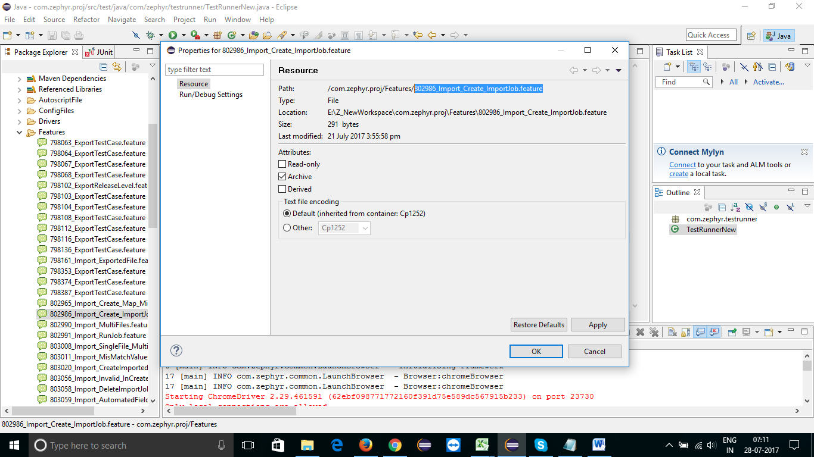

*Paste it in the TestRunnerNew.java class with forward slash as below : @CucumberOptions(feature={“Features/feature file name”})

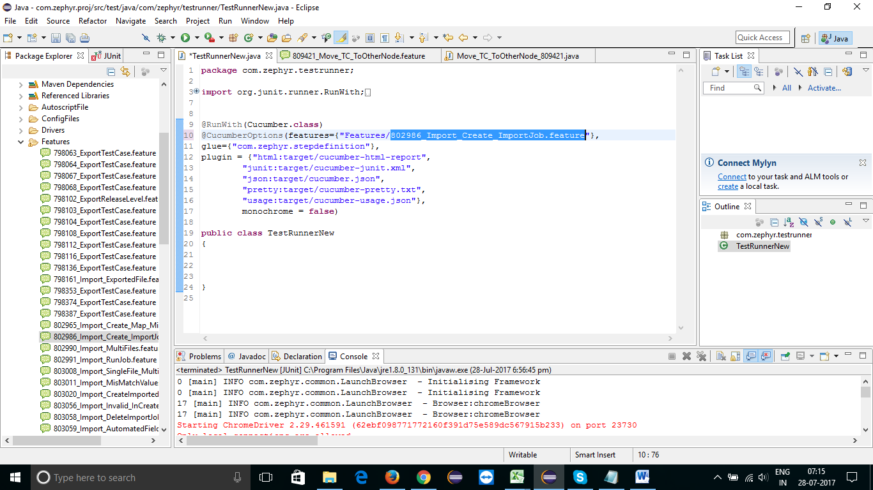

9.2 Run the Feature file

* Go to Package - >> src/test/java ->> com.zephyr.testrunner - >> TestRunnerNew.java ->>RightClick in TestRunnerNew.java class - >> Run As - >> JUnit Test

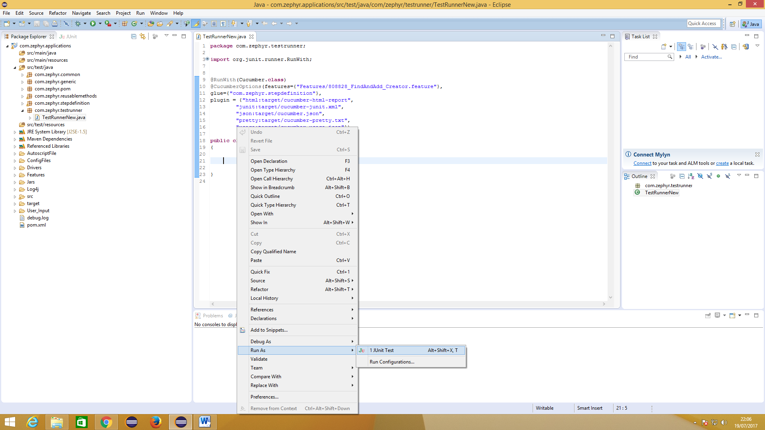

9.3 To Execute All the .feature files in a batch

* Go to ->> TestRunnerNew.java class ->> Mention only the Folder name (Where .feature files are batched into folder) ->> follow step 8.2

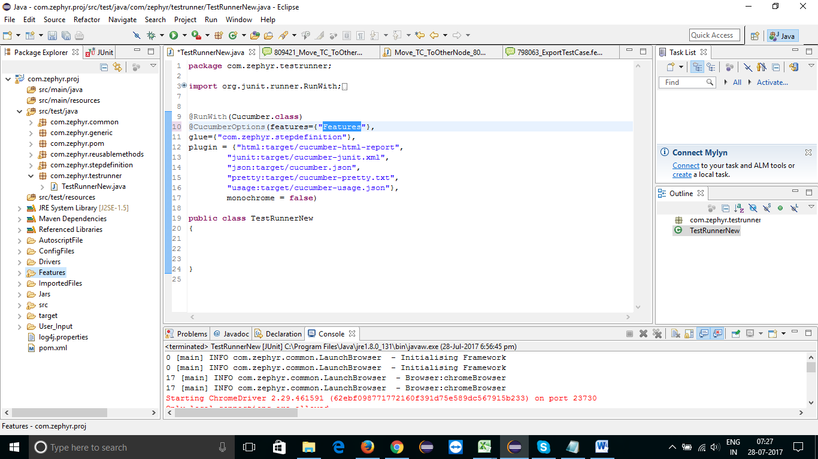

9.4 To Execute feature files in each Functionality level

* Go to ->> Functionality Master feature file (Ex: Create_FindAndAdd.feature) ->> Check the “tags” mentioned in all the Scenario of Master Feature file(Ex: @Create_FindAndAdd)

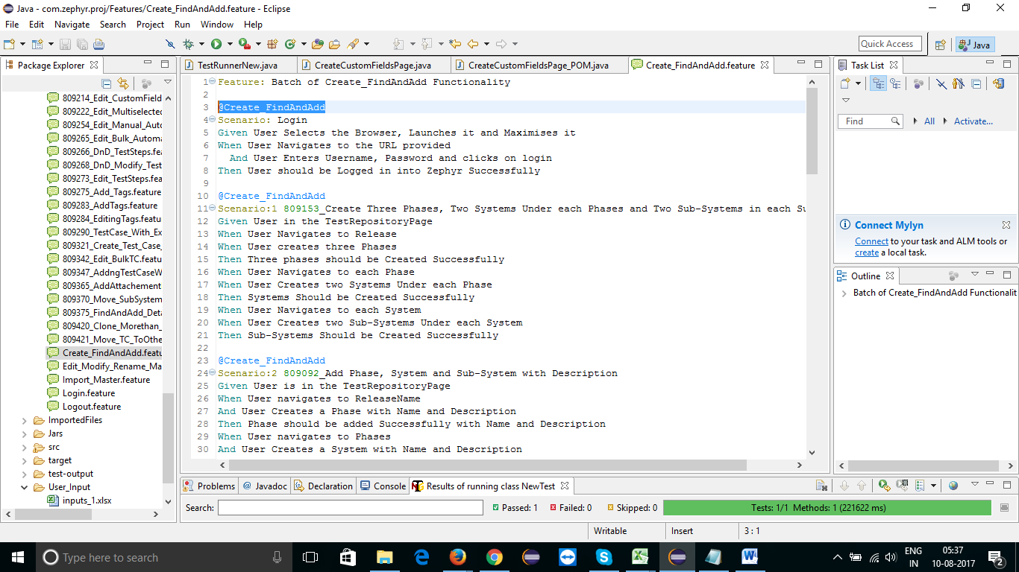

9.5 Mention the Tag name in the TestRunnerNew.java class and Run the Script using step 7.2

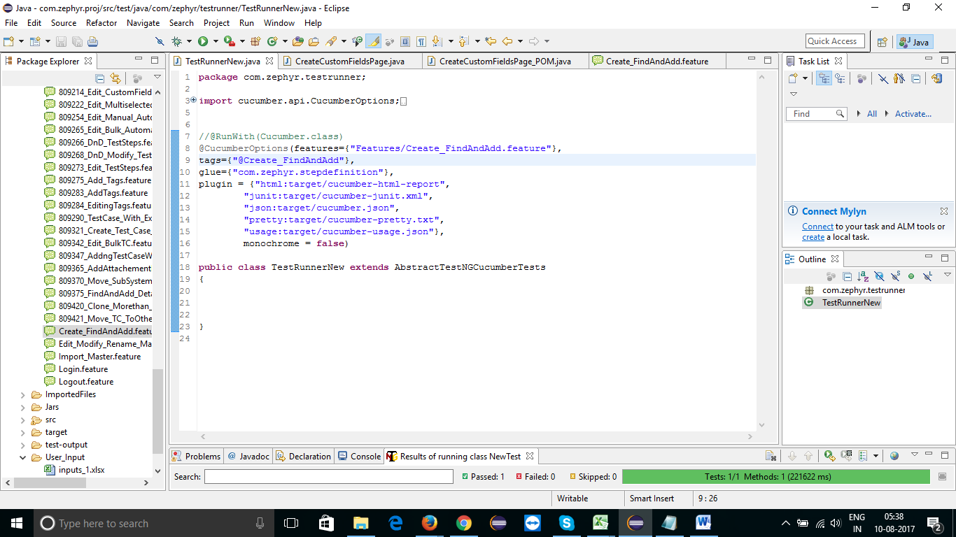

9.6 To Execute All Functionality Master Feature files together

* Go to ->> TestRunnerNew.java class ->> Mention the folder name of all the Feature files in cucumberOptions field ->>Mention tags of all the Master Feature file into the TetRunnerNew.java class “tags” ->> follow step 8.2

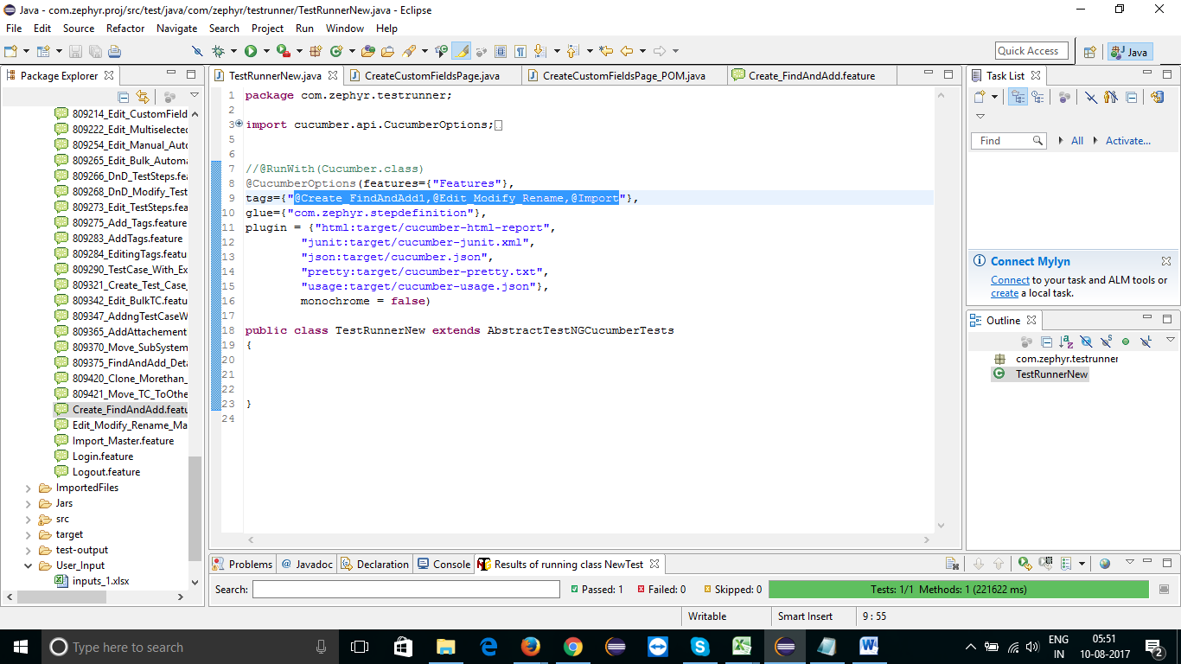

# 10. Download and Install Jenkins

10.1 Download Jenkins from the link - >> <https://jenkins.io/download/>

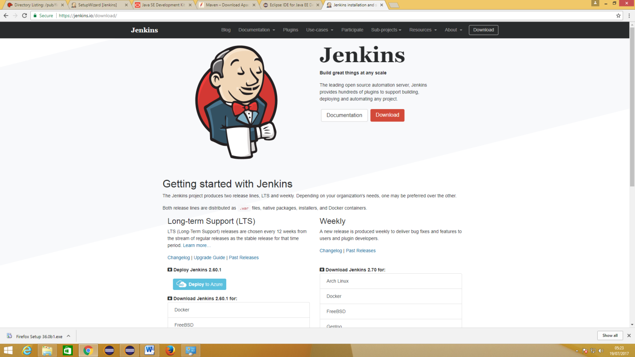

10.2 Extract and Install it and Create User

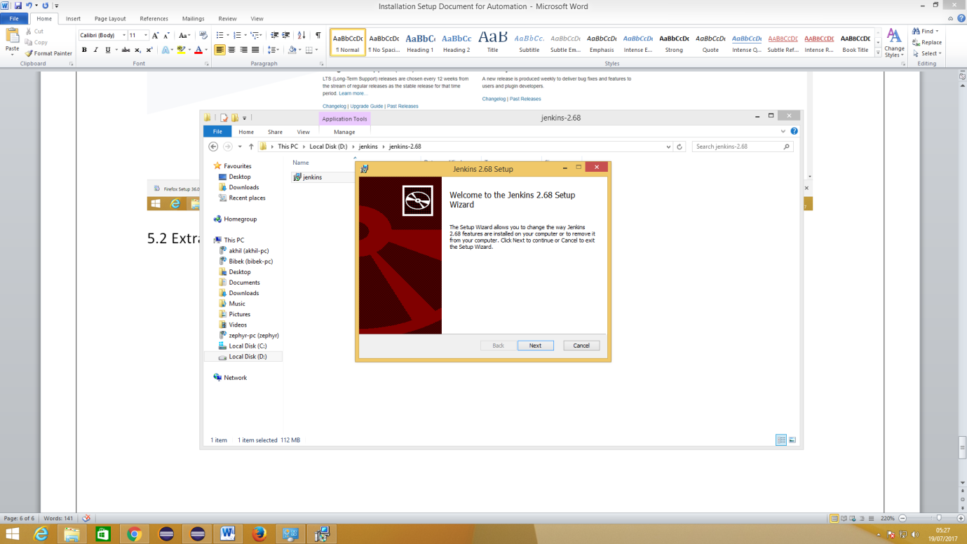

10.3 After installing and User Creation for Jenkins, the Jenkins window Looks like below

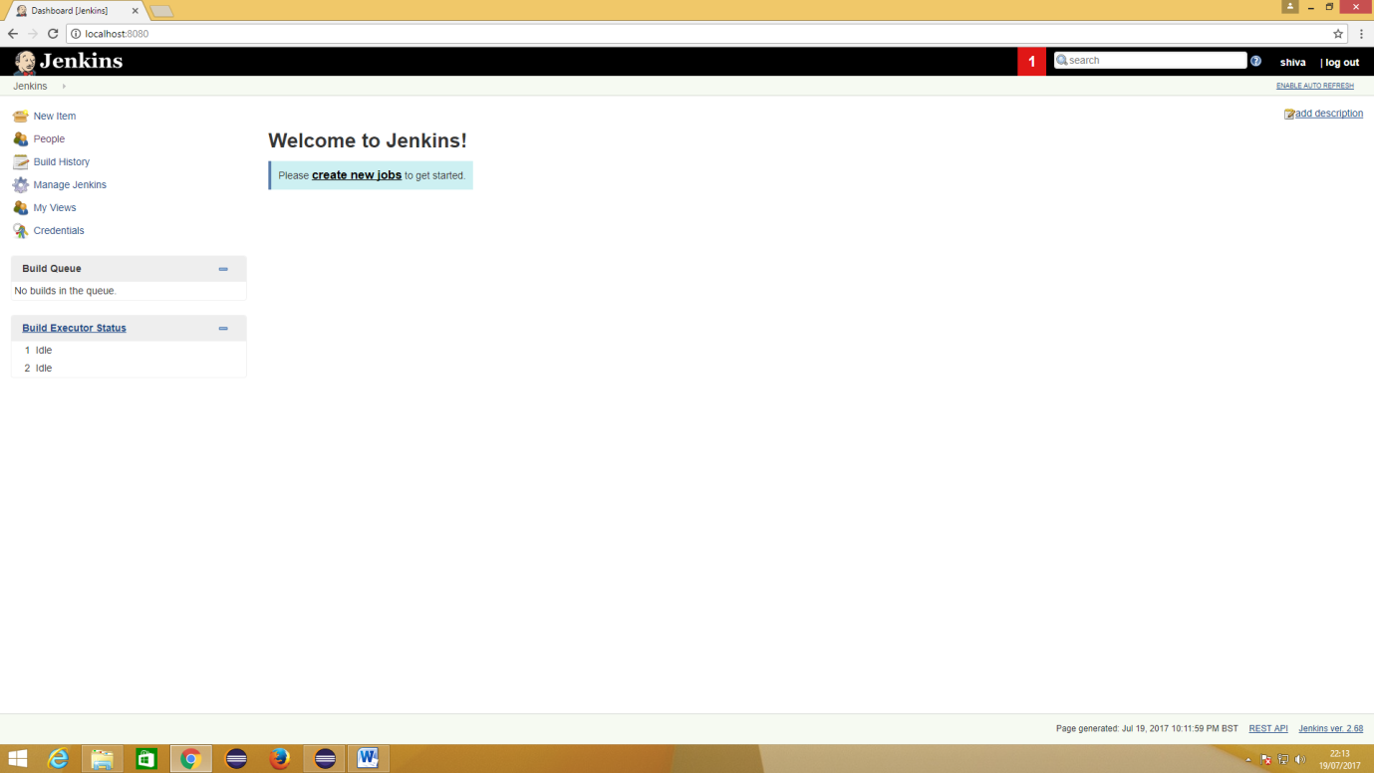

10.4 Create and Build a Project through Jenkins

*Click on ->> manage Jenkins ->> manage plug-in ->> available ->> Search for “Maven” ->> Add 3 plug-in mentioned below - >> Install without Restart

1. Maven Integration Plug-in 2.Maven info plug-in 3.Maven Repository server plug-in

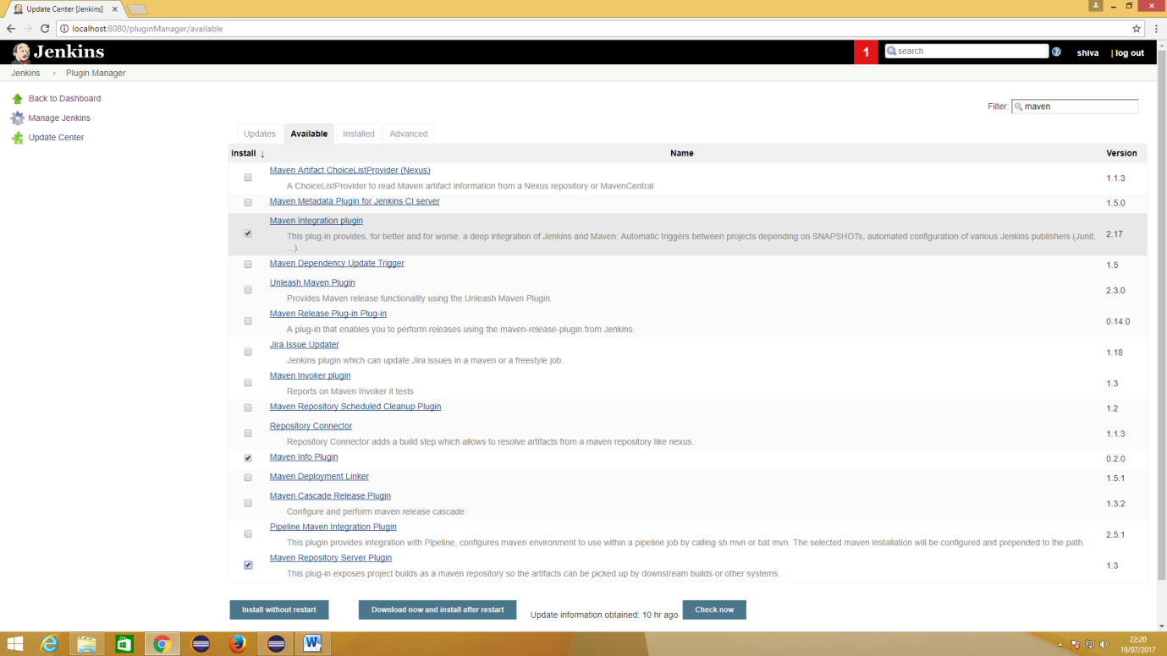

*Search for below mentioned cucumber plug-in and Install without Restart

1. Cucumber reports

2. Cucumber trend reports

*Go to ->> manage Jenkins ->> Global tool Configuration ->> Set installation path for JDK and MAVEN

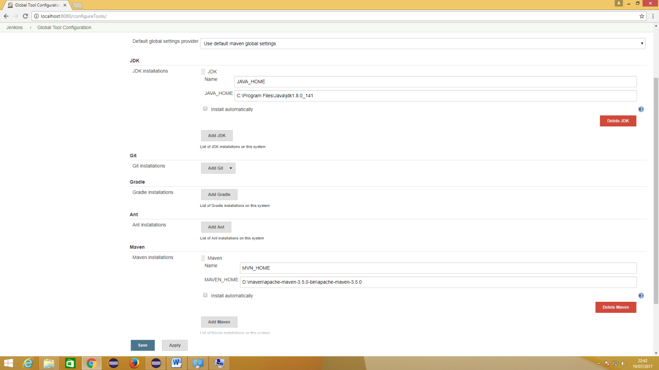

*Go to ->> Dashboard ->> New Item ->> Give Build name(Ex:Test1) ->> Select Maven Project ->> click on OK

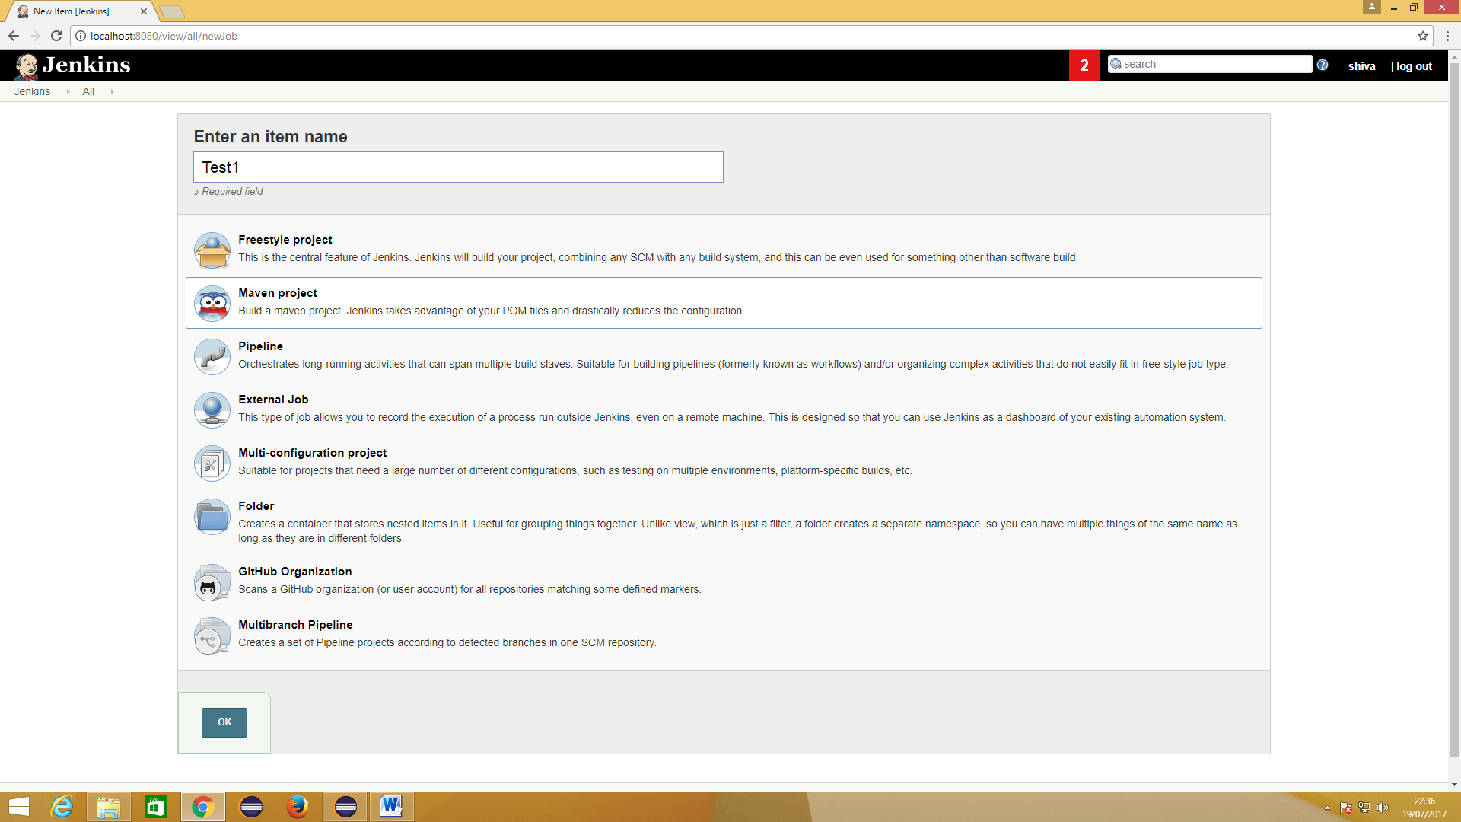

*Go to ->>Build Environment ->>

ROOT POM : set the path of pom.xml file from maven project in Eclipse

Goals and Options : clean install

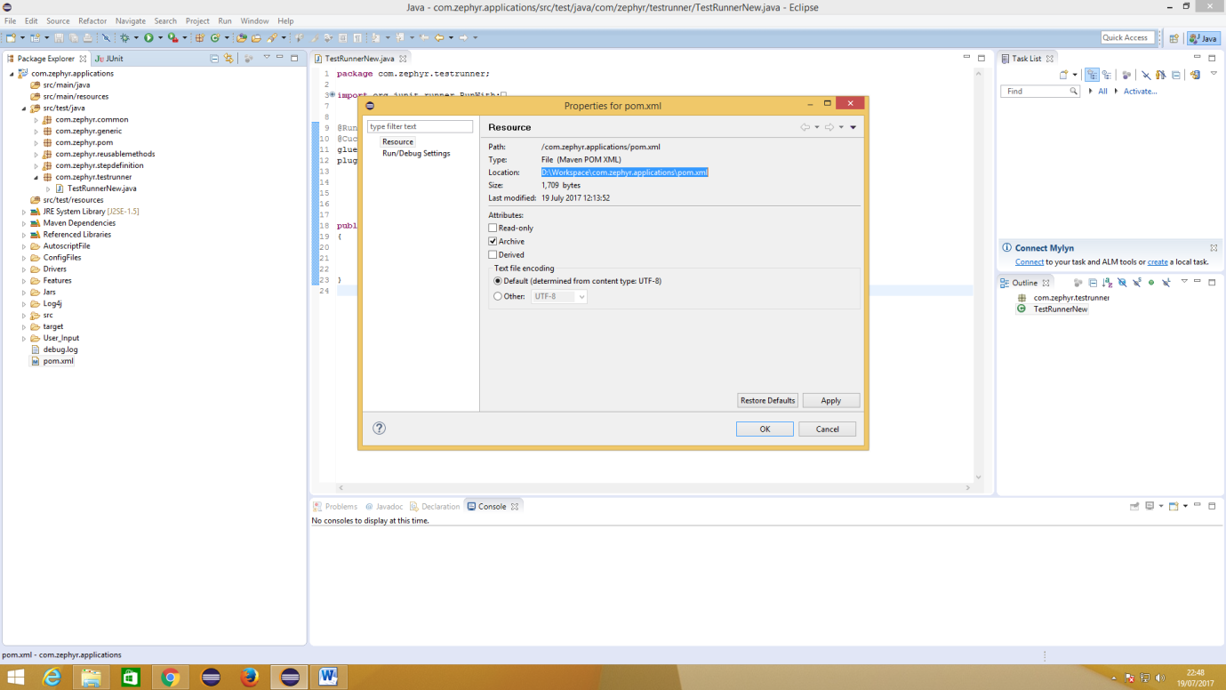

*Go to ->> Post Build Actions ->>Select Cucumber Reports ->> Advanced

Report Path: path of target folder of the maven project in Eclipse

File Include Pattern: cucumber.json - >> Apply - >> Save

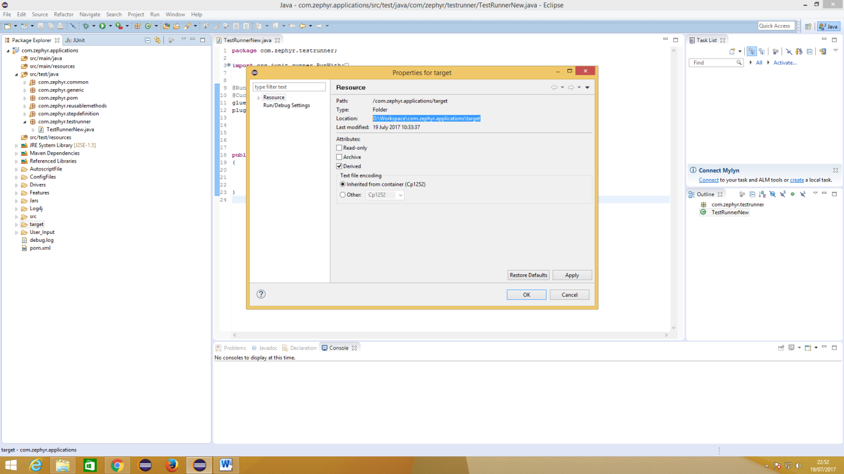

*Path setting window looks like below

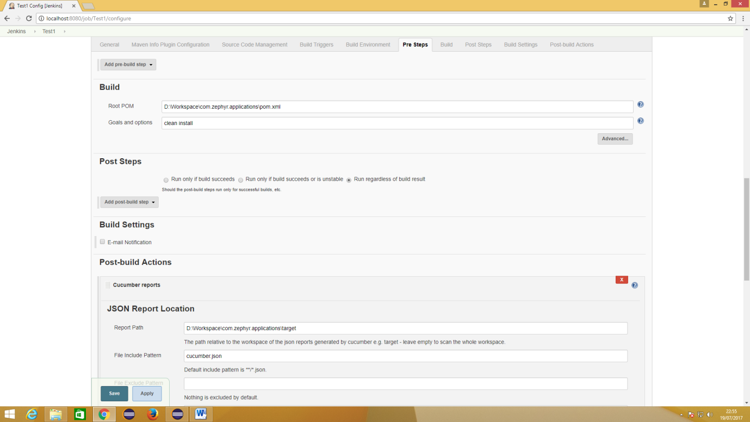

*Click On ->> build now ->> Console Output (To see actions performing as feature file steps)

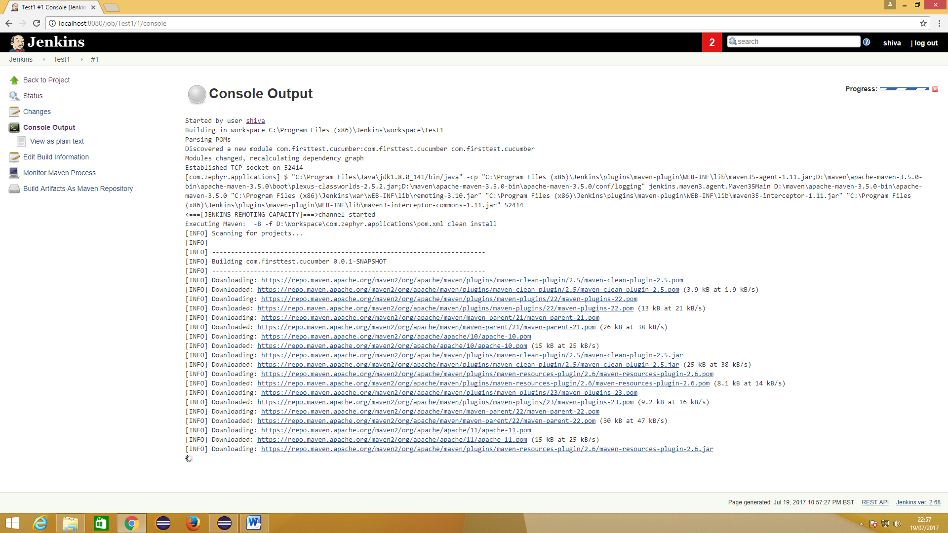

*Wait up to

1. Jenkins downloads all the Maven Dependency jars

2. It Runs the Test1 you have mentioned in TestRunnerNew.java class

3. It Displays ‘Build Success’ msg.

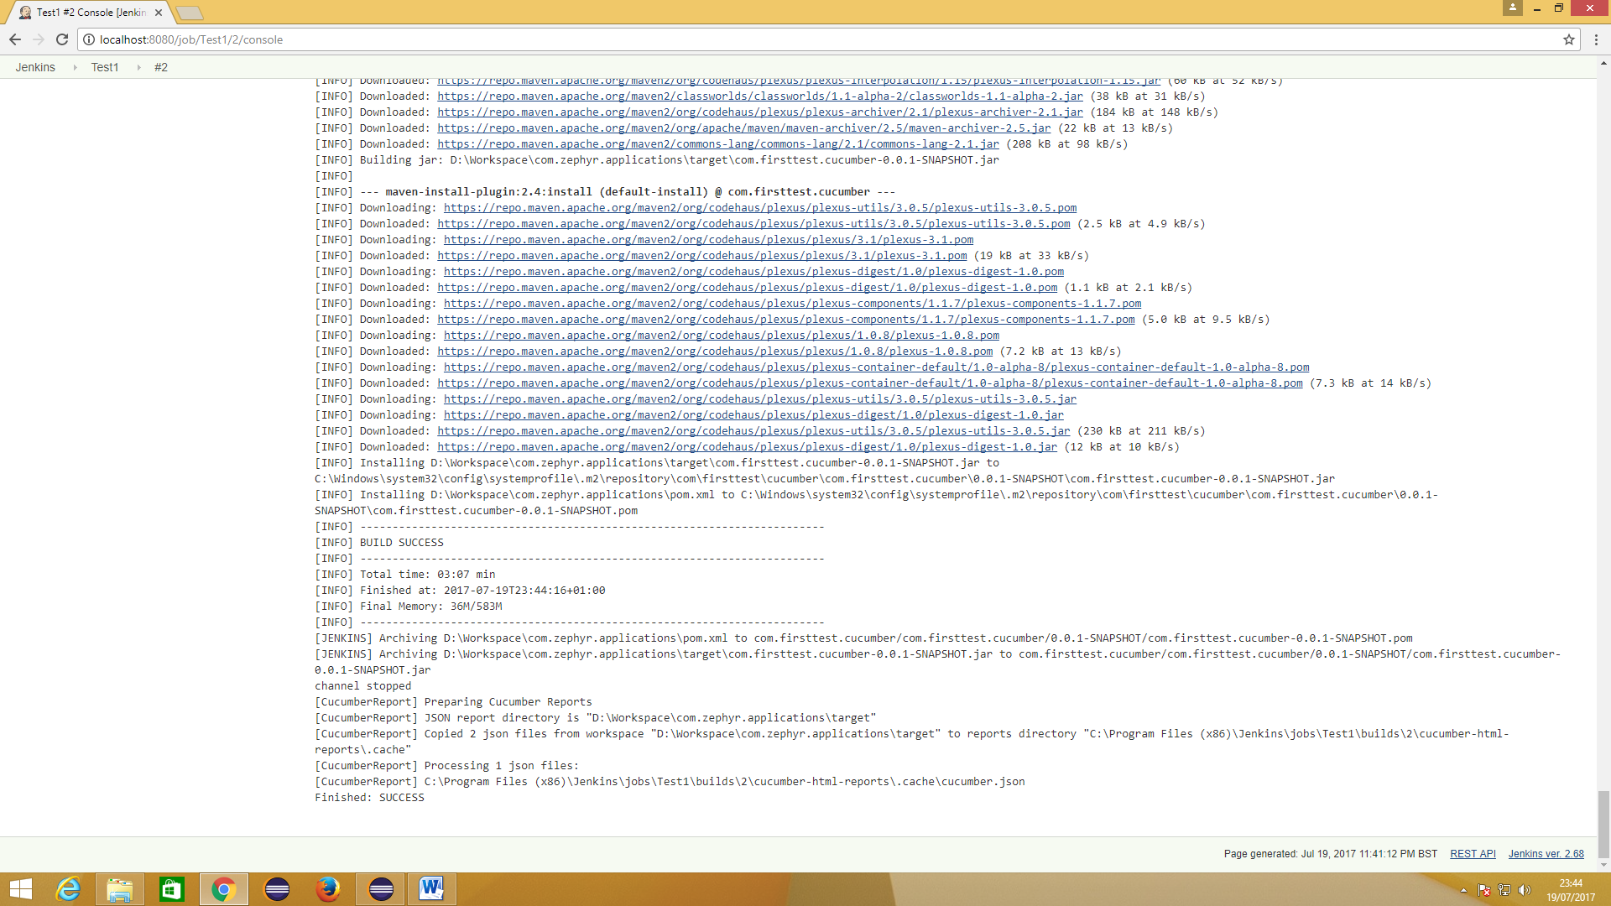

10.5. You can see the reports with Feature, Scenario and Step in ‘Cucumber Reports’ Icon in the Jenkins Project

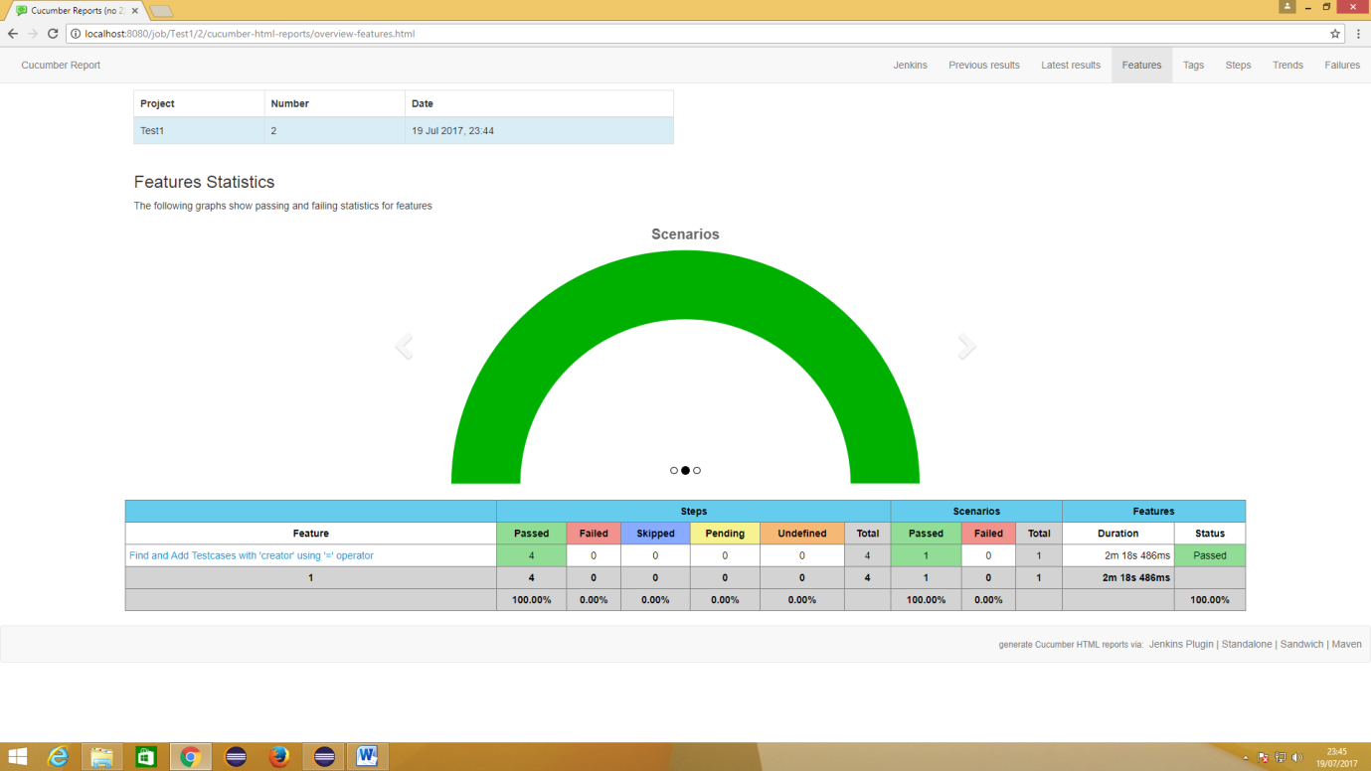

# 11. Clone the Code from Stash and Import the same folder to Eclipse

11.1 Clone the Latest code from Stash

* Copying the link specified in stash repository -- >> Stash ->> Projects ->> Repository ->> Click on Latest Version of Code - >> Options ->> Clone - >> Copy the Link

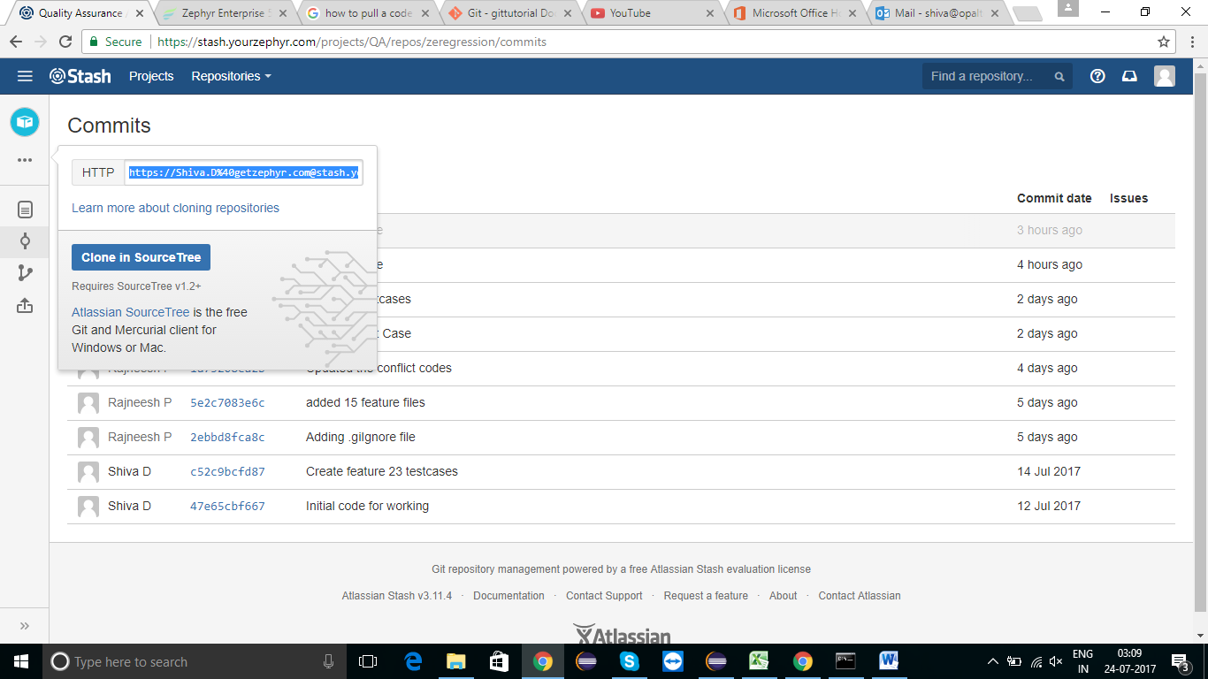

* Create a Specific folder in your Local Workspace, from the Folder Switch to Command Prompt - >> git init - >> git clone path (copied link) - >> Press Enter and Wait up to It clones all the Latest Version of code to your Workspace

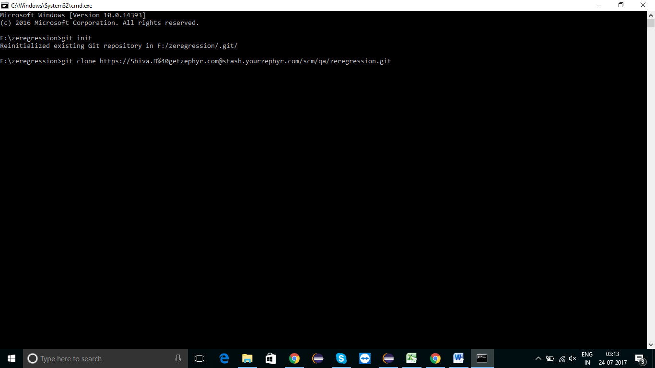

11.2 Import that Folder to the Eclipse Workspace By following above step (4.2)

11.3 Run it by Using Step (8)

# 12. Limitations of Automation Project

* Appropriate Browser Driver.exe file & Standard Browser versions should be used.
* We should use Windows Environment to run all the Scripts.

# 13. How to rerun the failed test scripts

1. After executing from test runner class, if any failure occurred then, check the rerun.txt file which is present inside the target folder.

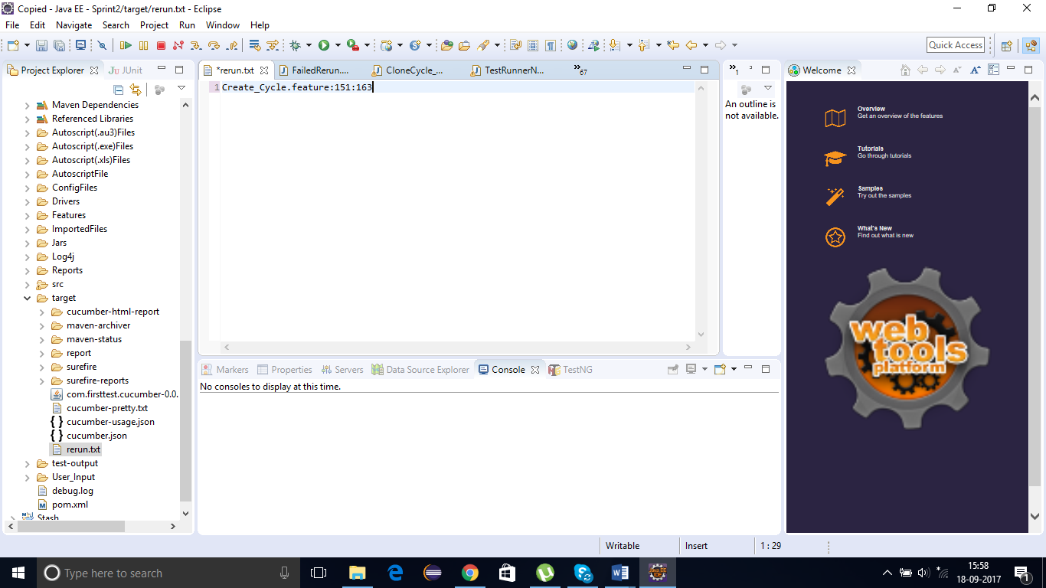

1. The failure feature files will be listed programmatically with the scenarios respectively, separated by semicolon (:).
2. The number indicates the failure scenario line number (e.g.- Create_Cycle.feature:151:163)
3. Include the login and logout scenario line number of failed master feature file (e.g.-- Create_Cycle.feature:4:151:163:63). (here 4 indicates login scenario line number of Create_Cycle.feature and 63- indicates logout scenario line number of Create_Cycle.feature)

Like these mention login and logout scenario for all failure features file.

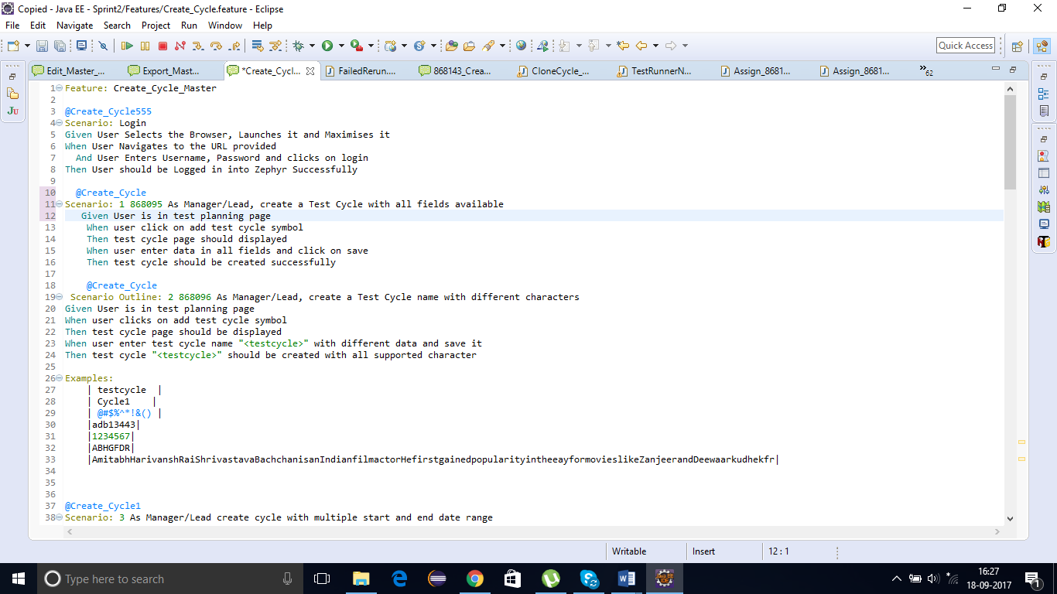

1. Copy paste the data after Features word in Failed Scenario class present in

com. zephyr.testrunner package.

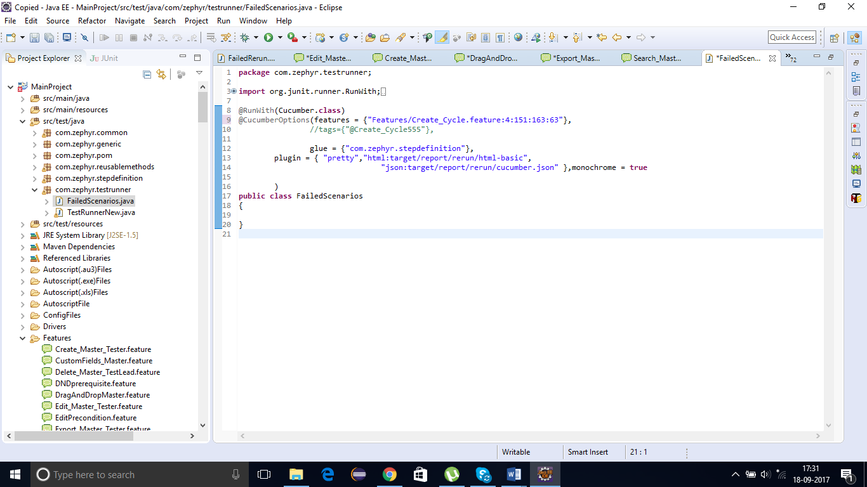

1. Execute the Failed Scenario class